AZURE MONITORING
INTRODUCTION; Azure Monitor is a monitoring service in Microsoft Azure that collects, analyzes, and responds to telemetry data from Azure resources such as Virtual Machines.
It helps in performance monitoring, log analysis, and alert management.
Architecture Overview;
The monitoring architecture consists of the following components:
- Virtual Machine (VM)
- Azure Monitor
- Log Analytics Workspace
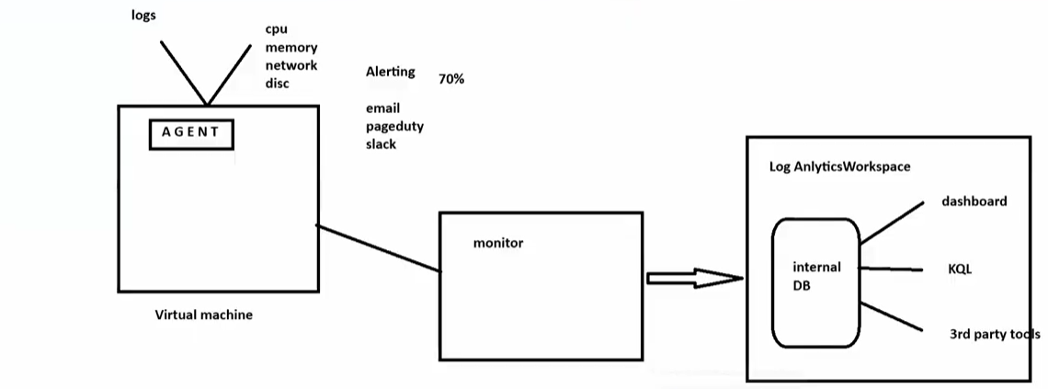
- Virtual Machine and Agent
An Azure Virtual Machine is installed with a monitoring agent.
The agent collects the following data:
- CPU usage
- Memory usage
- Network activity
- Disk performance
- System and application logs
This data is sent to Azure Monitor for analysis.
- Azure Monitor
Azure Monitor receives telemetry data from the virtual machine.
It performs the following functions:
- Analyzes performance metrics
- Evaluates alert conditions (Example: CPU usage > 70%)
- Sends alerts via Email, Slack, or other notification services
- Log Analytics Workspace
Log Analytics Workspace stores all collected log data.
Features:
- Internal database for log storage
- KQL (Kusto Query Language) for querying logs
- Dashboards for visualization
- Integration with third-party tools
Users can write KQL queries to analyze performance and troubleshoot issues.
Step 1: Create Virtual Machine;
1.Go to Virtual Machines.
2.Click Create → Azure Virtual Machine.
3.Enter VM name, region, image, size.
4.Configure username and password.
5.Click Review + Create → Create
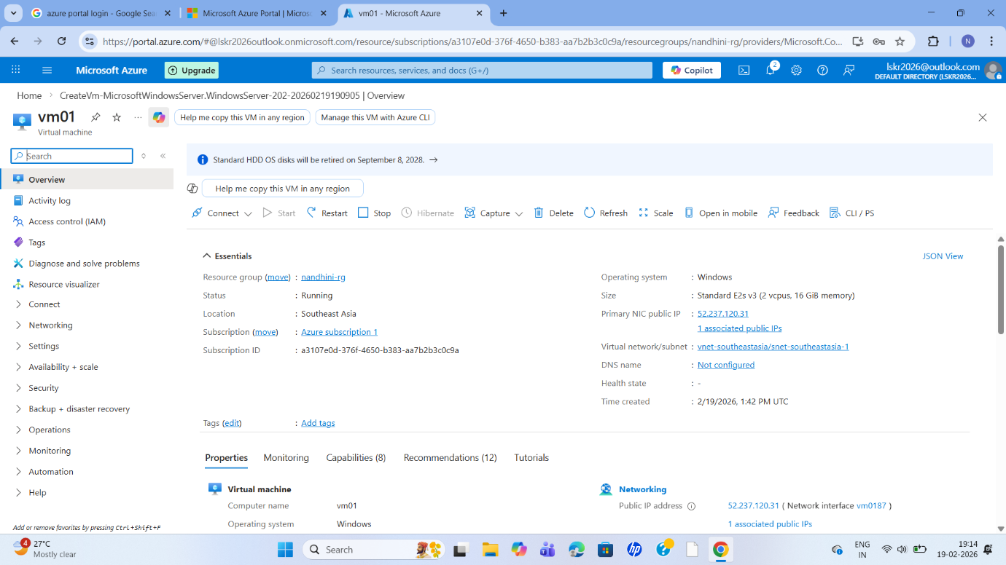

Step 2: Create Log Analytics Workspace
- Login to Azure Portal.
- Search for Log Analytics Workspace.
- Click Create.
- Select Subscription and Resource Group.
- Provide Workspace Name.
- Click Review + Create → Create.
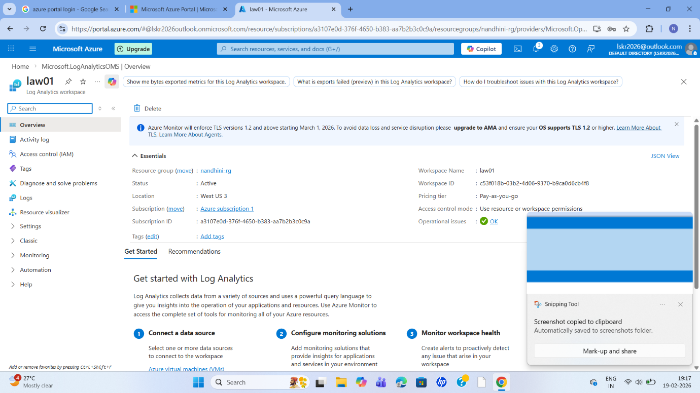
Step 3: Enable Monitoring
- Open the created VM.
- Go to Monitoring section.
- Click Insights → Enable.
- Select the created Log Analytics Workspace.
- Click Enable.
Azure Monitor Agent will be installed automatically.
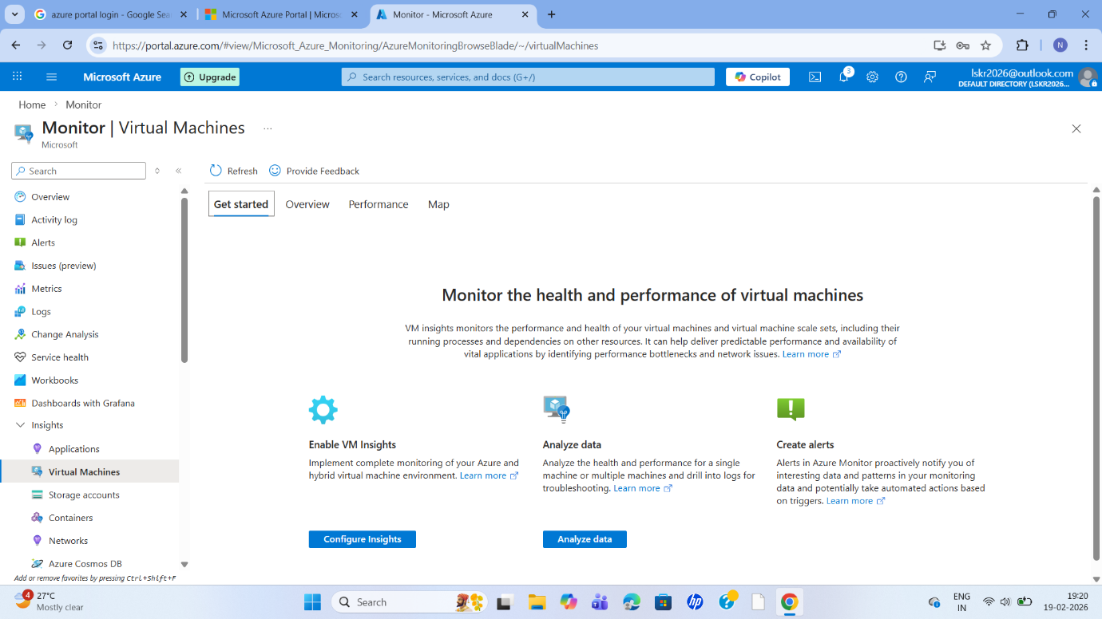
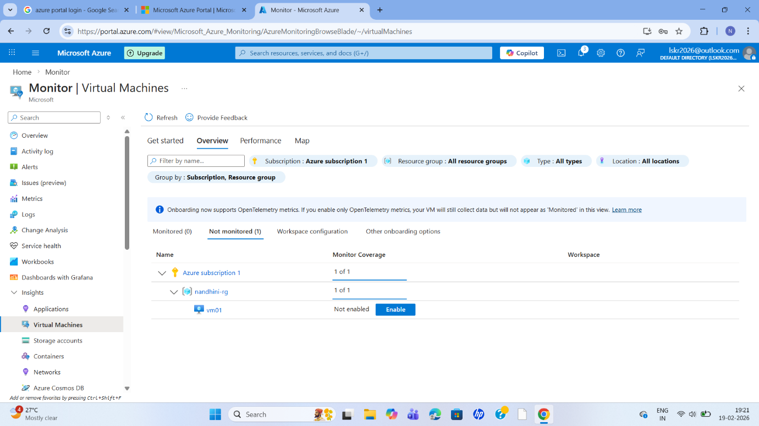
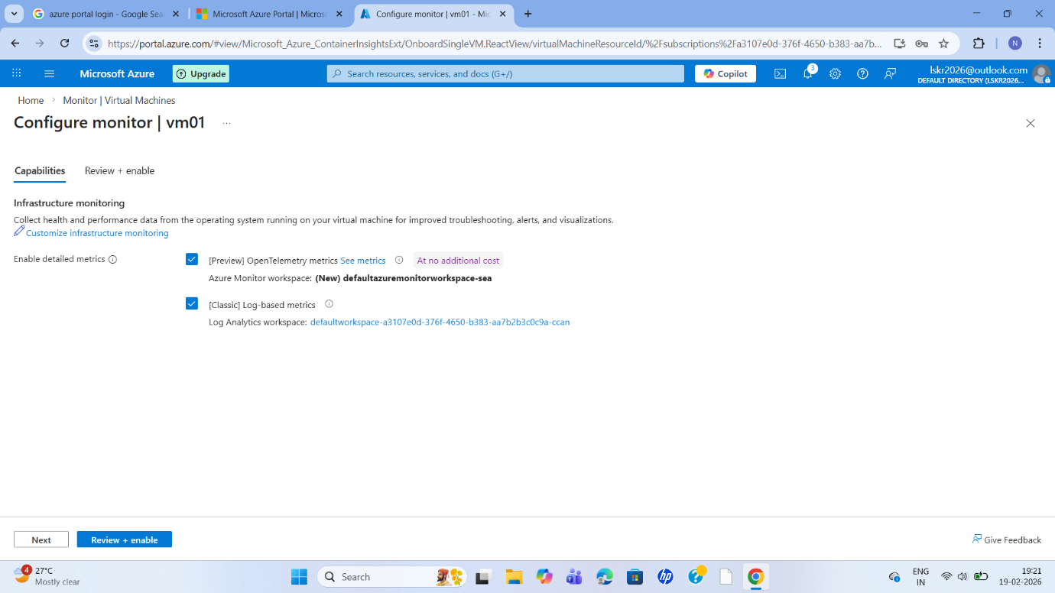
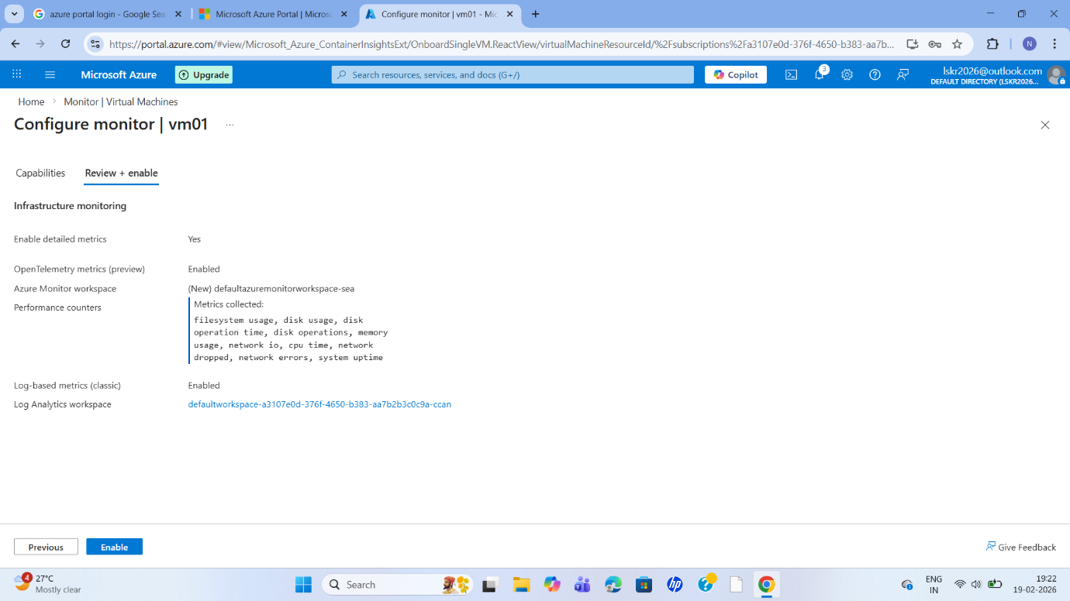

Step 4: Create Storage Account
- Search → Storage Accounts
- Click Create
- Select:
  - Subscription
  - Resource Group
  - Storage Account Name (example: monitorstorage01)
  - Region (same as VM)
- Performance → Standard
5.Click Review + Create → Create
- Storage Account created successfully.

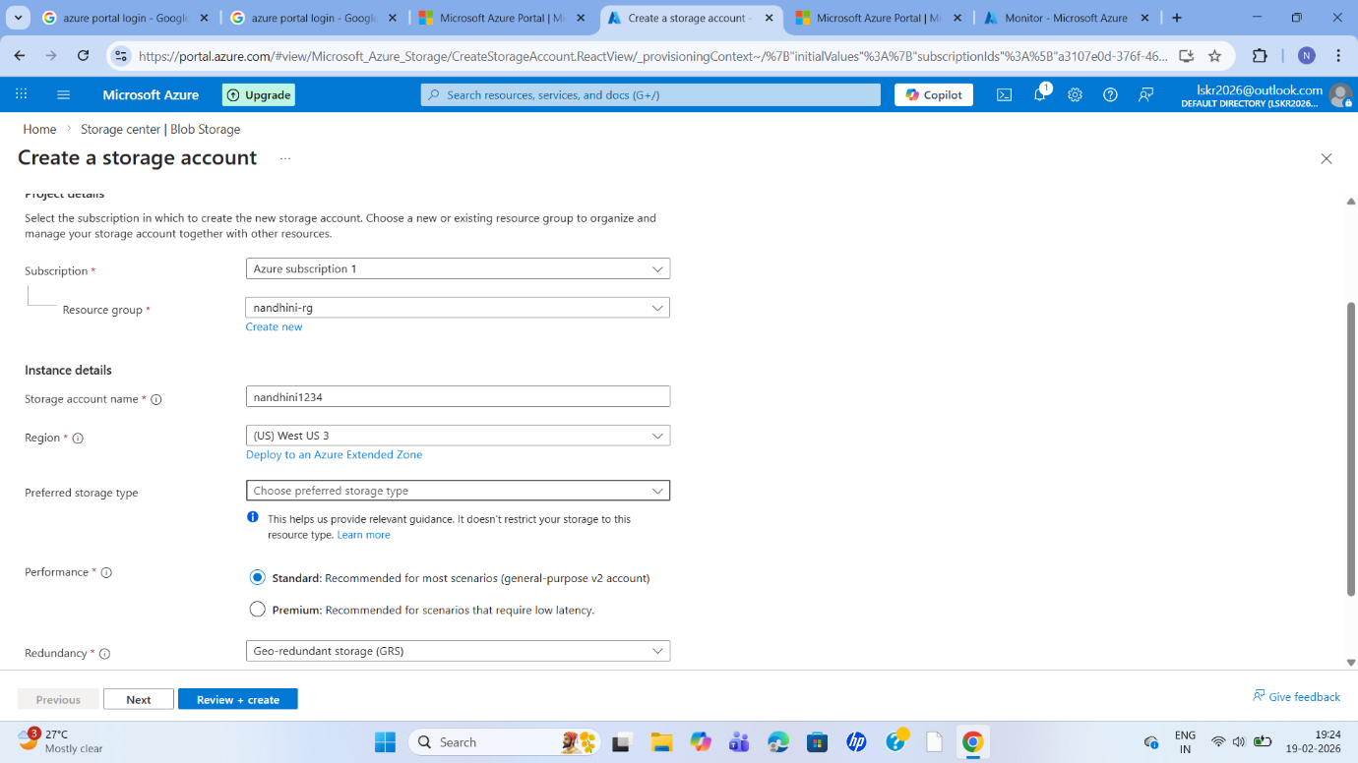
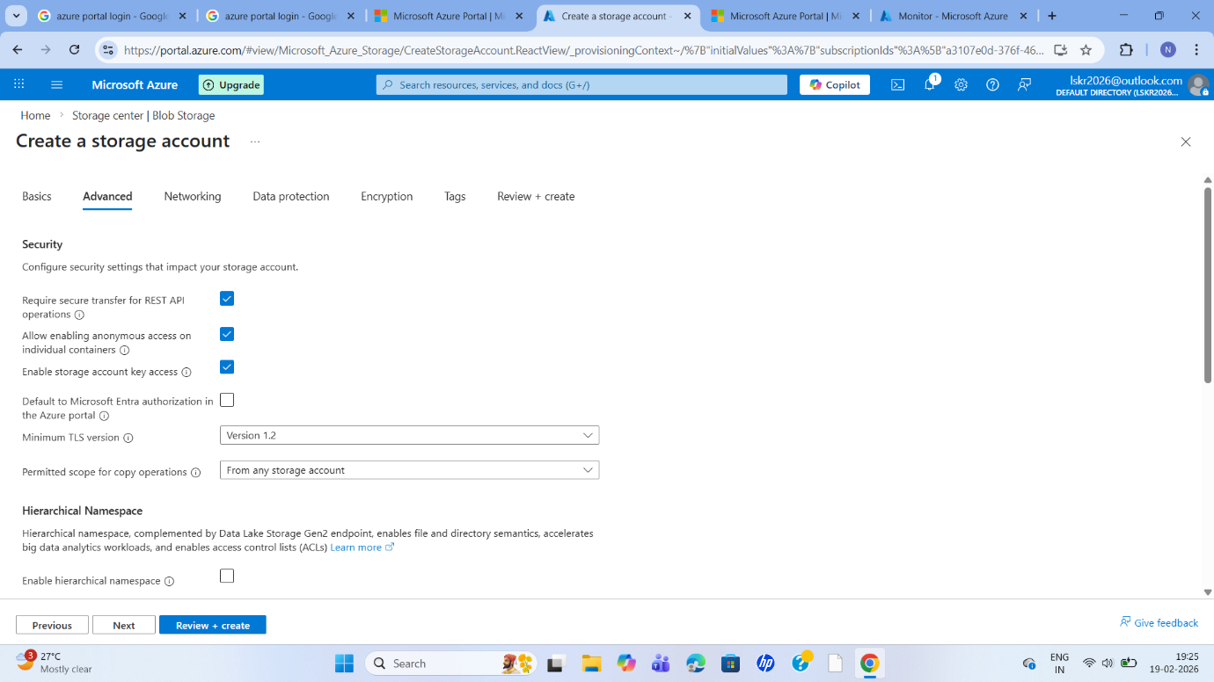

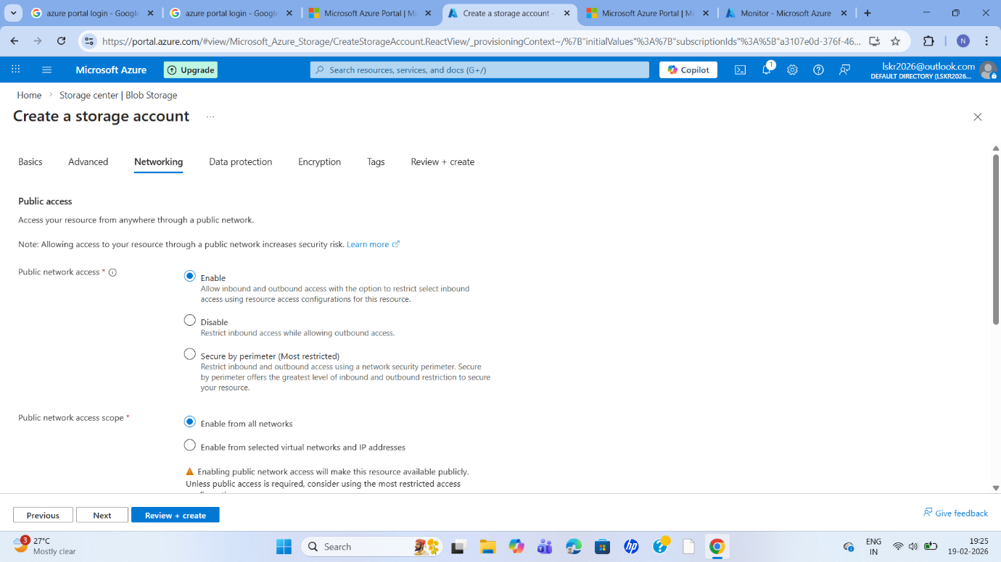
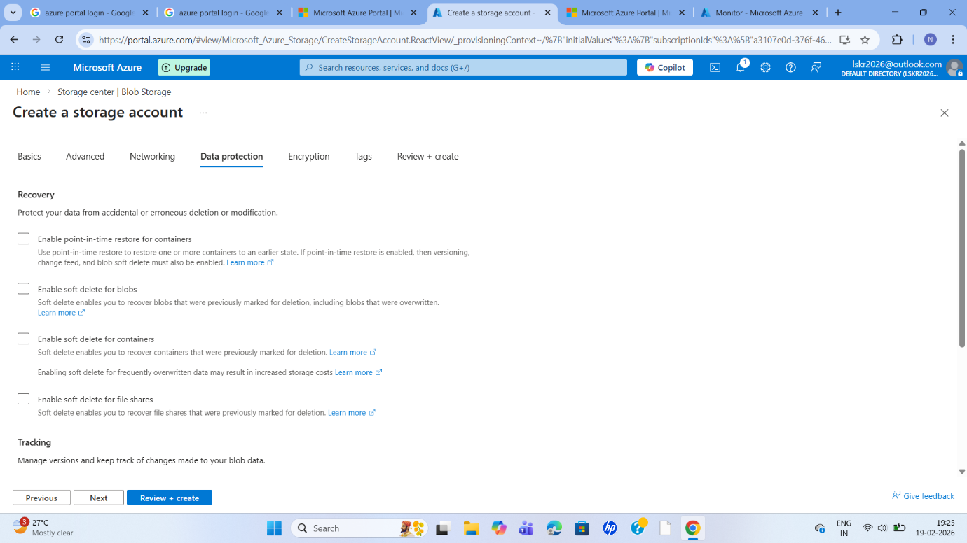
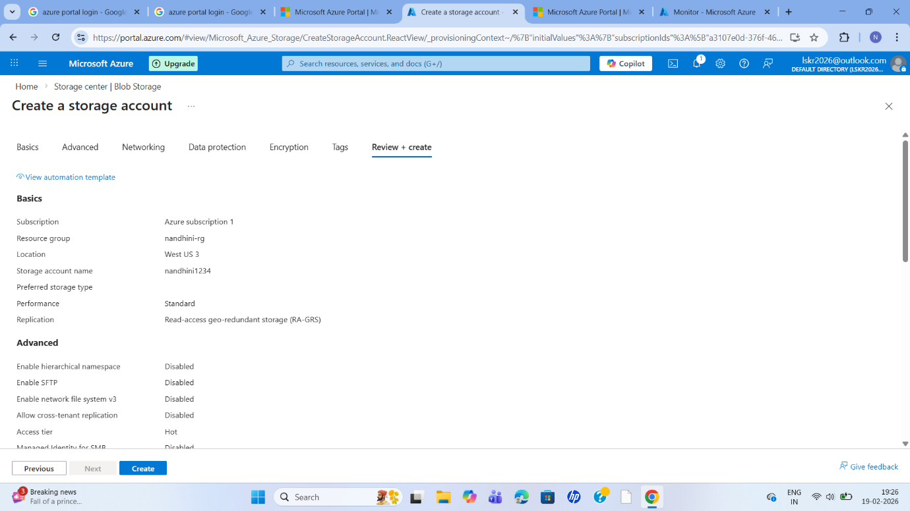
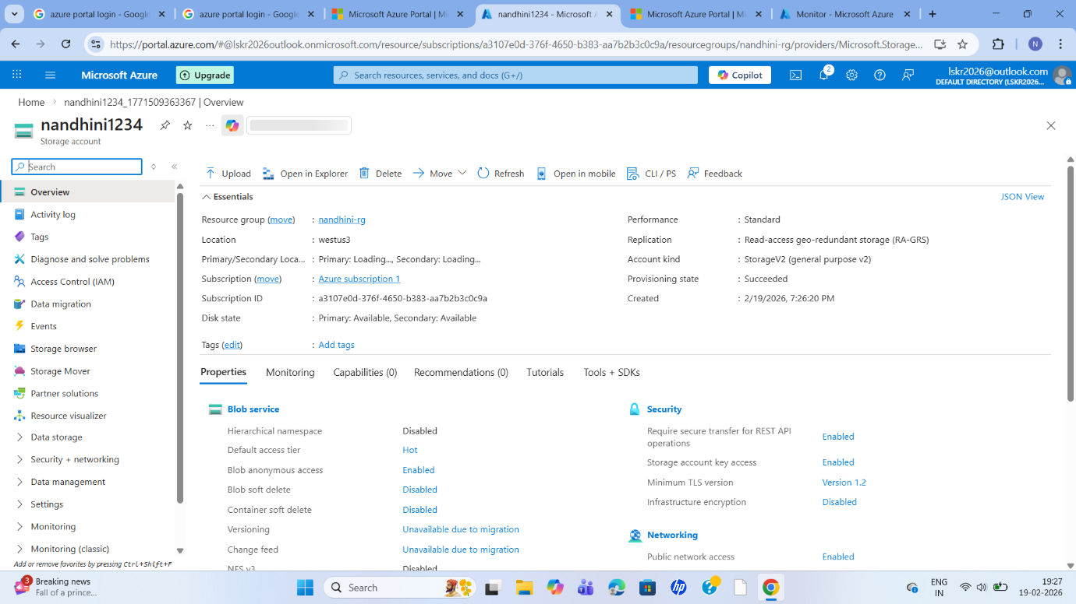
The virtual machine has been successfully added to azure monitor and monitoring is enabled,
so this machine will be monitor by your azure monitor.
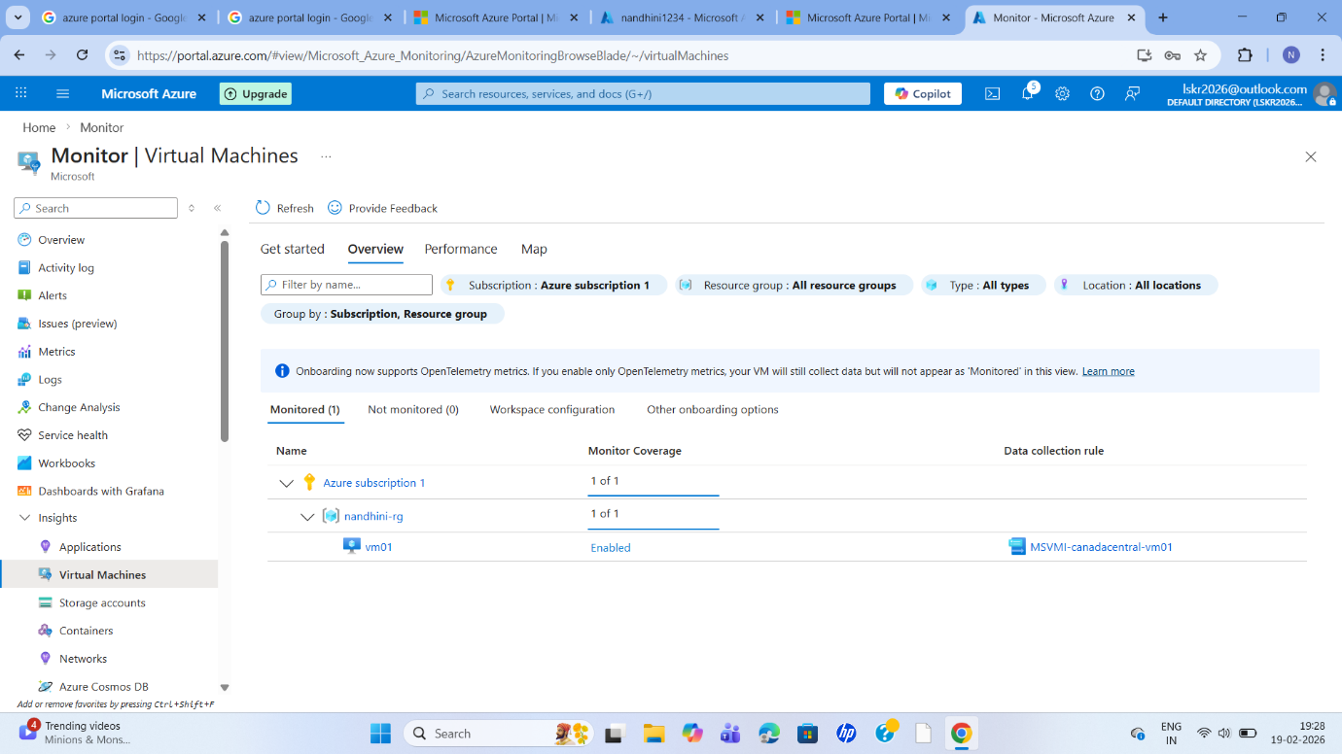
Again when i go back here, refresh
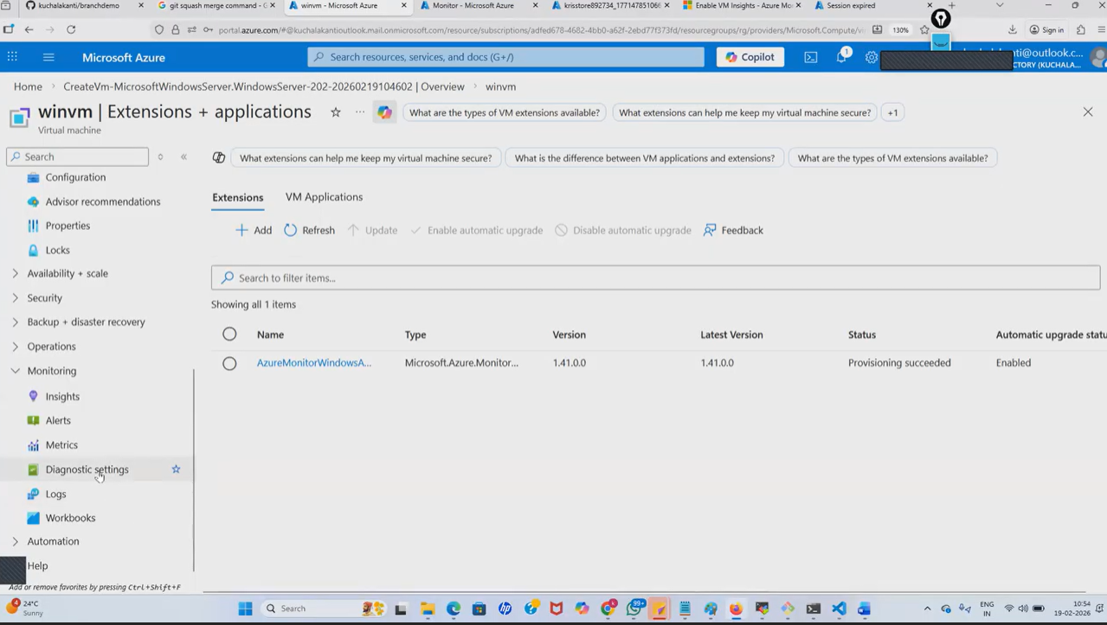
Diagnostic settings - virtual machine
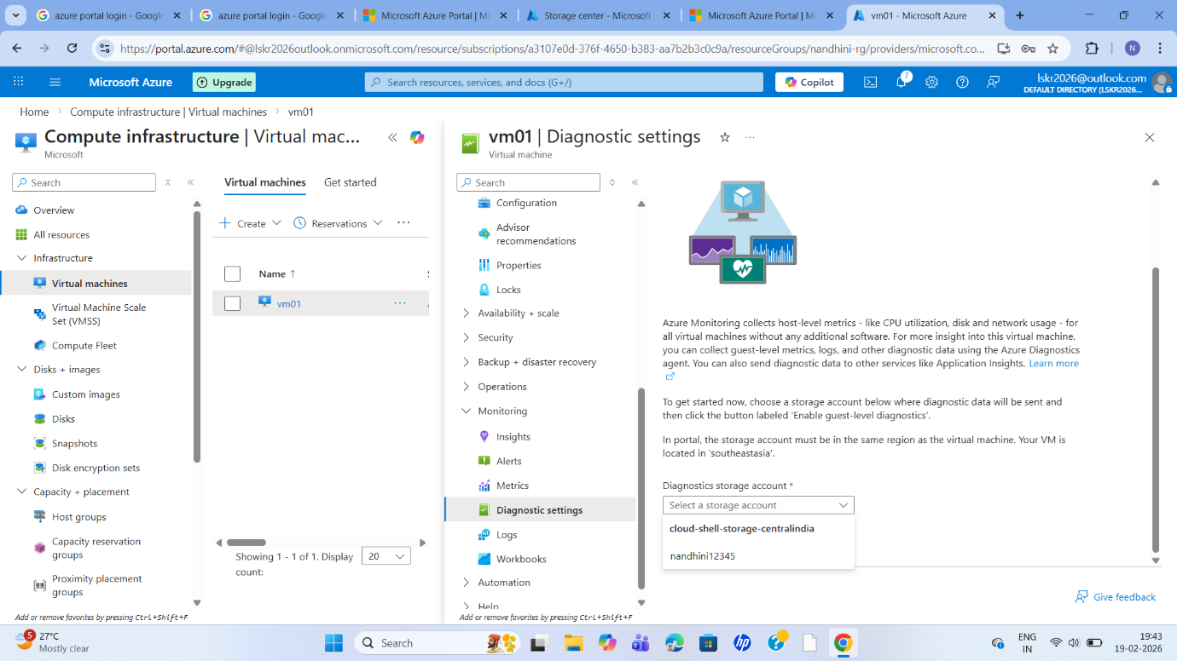
Select the storage account

Enable guest level monitoring here.
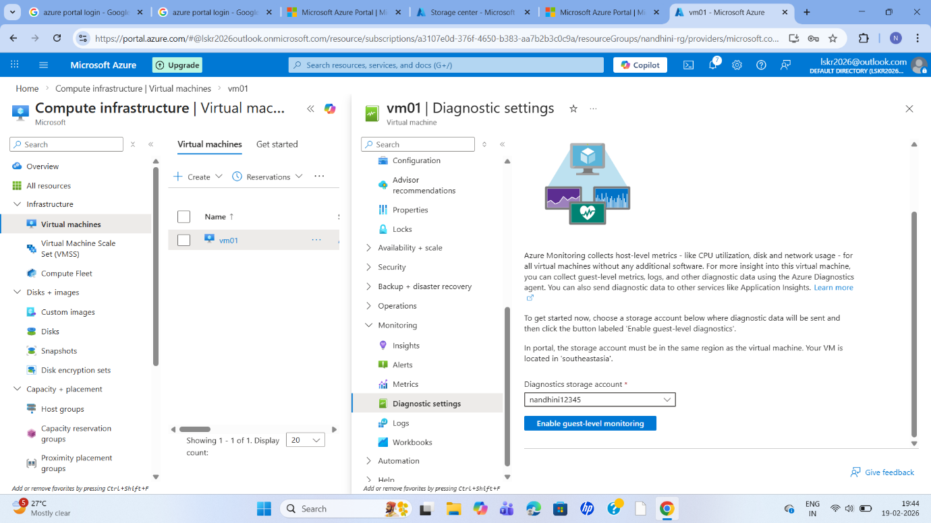
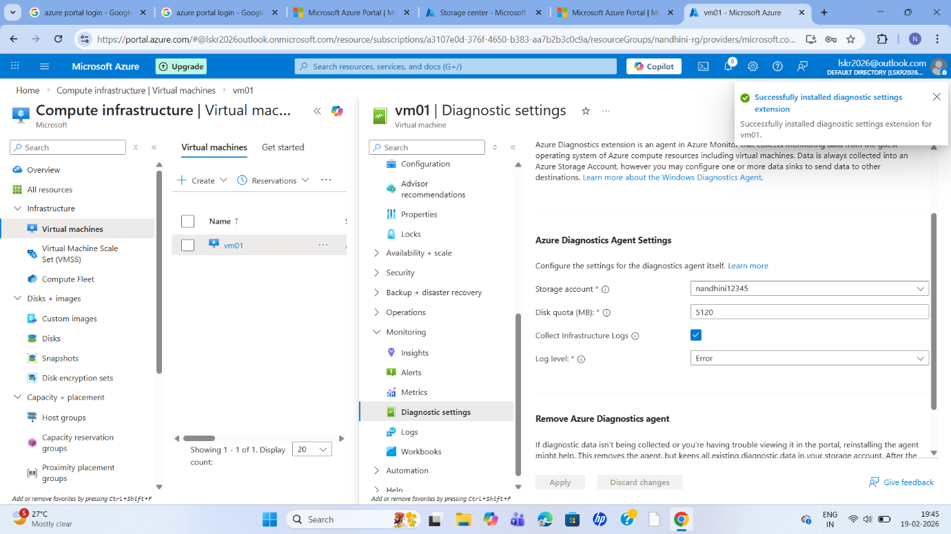
And at the same time I am going to performance counter
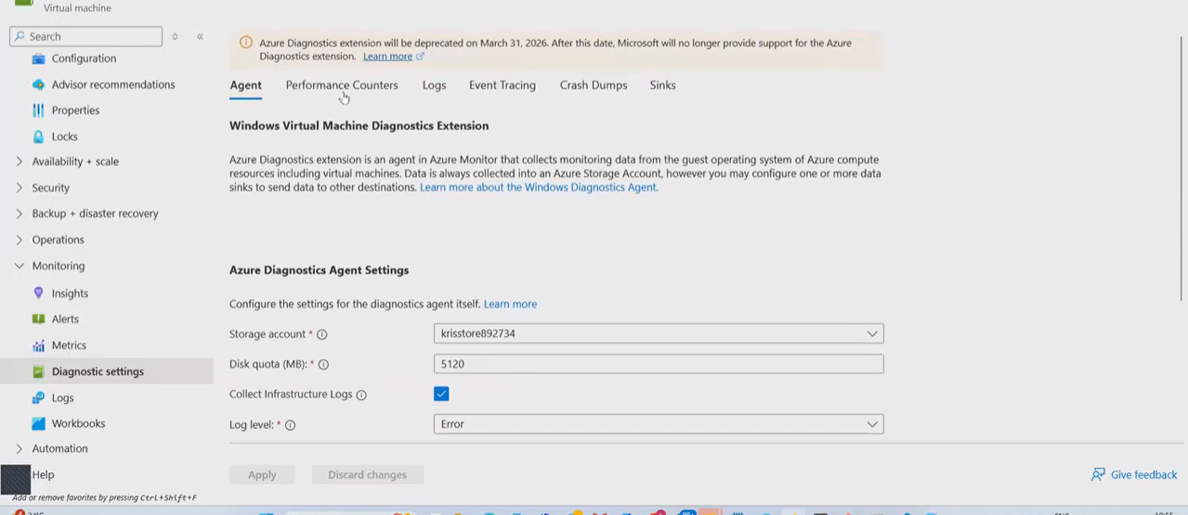
These are the counter it is going to add
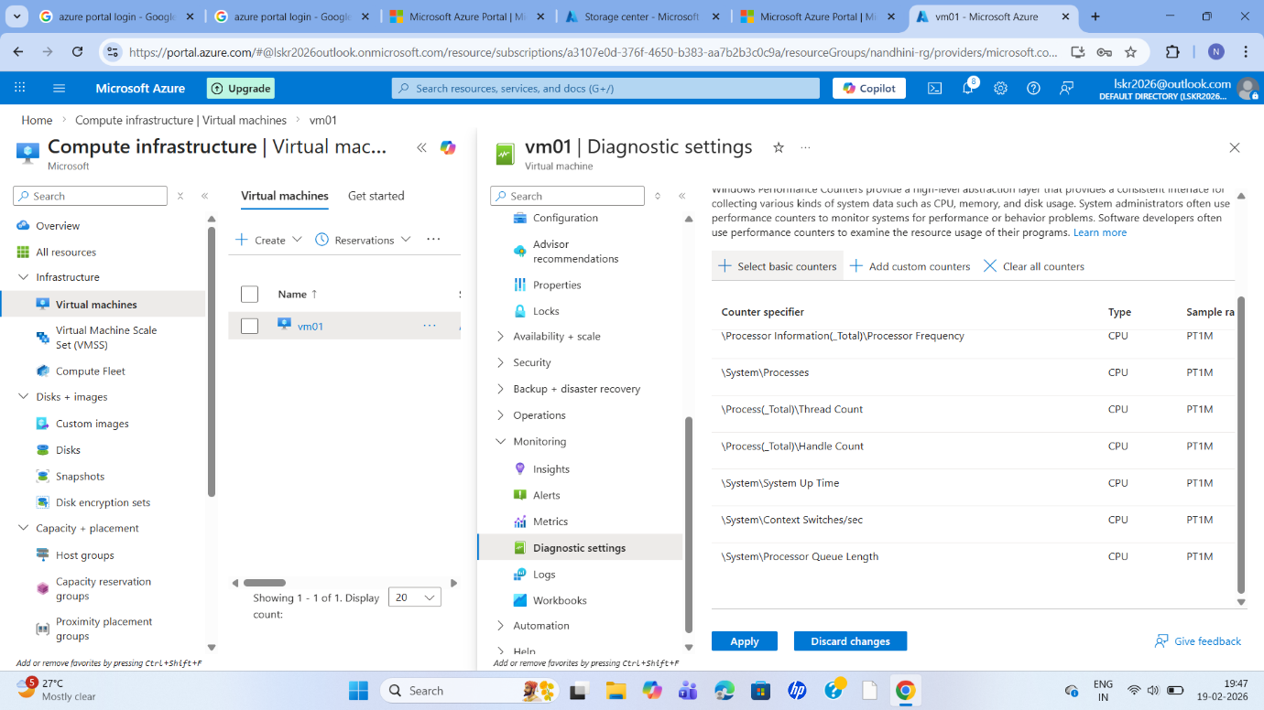
so if you going to select the basic counters
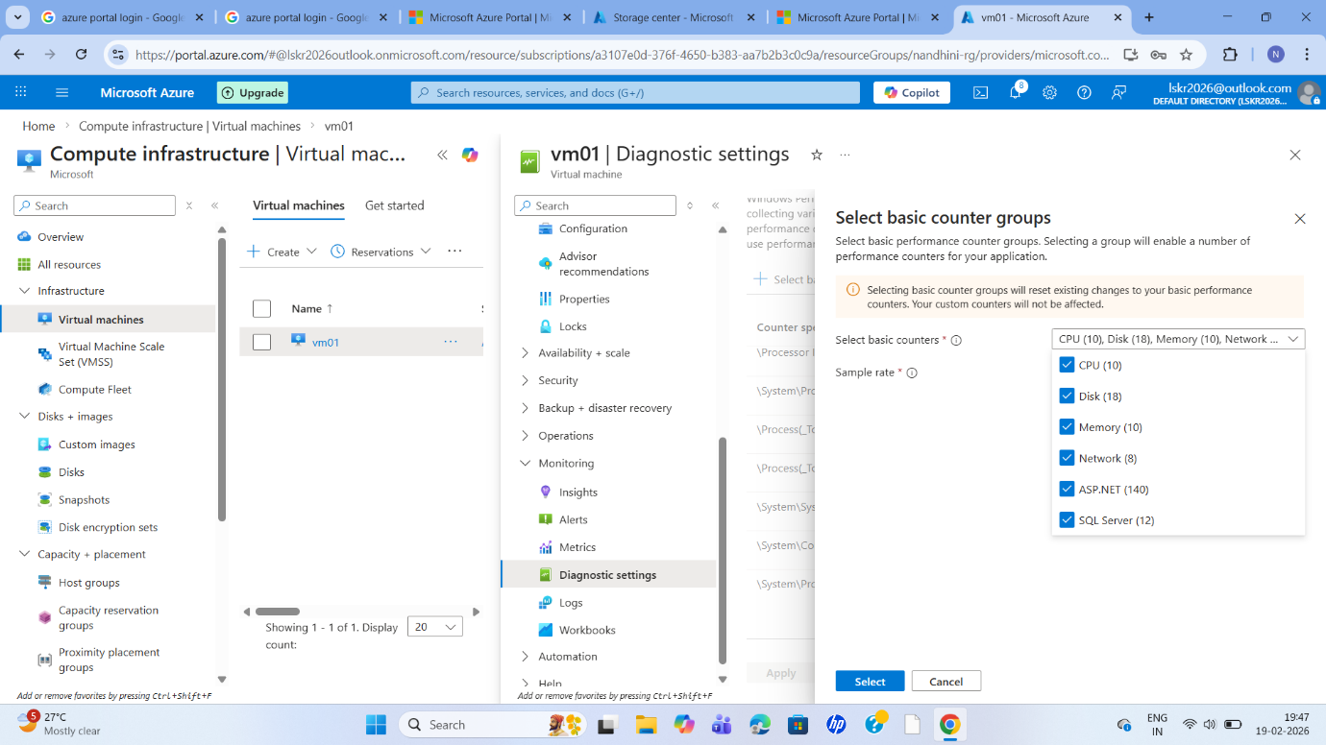
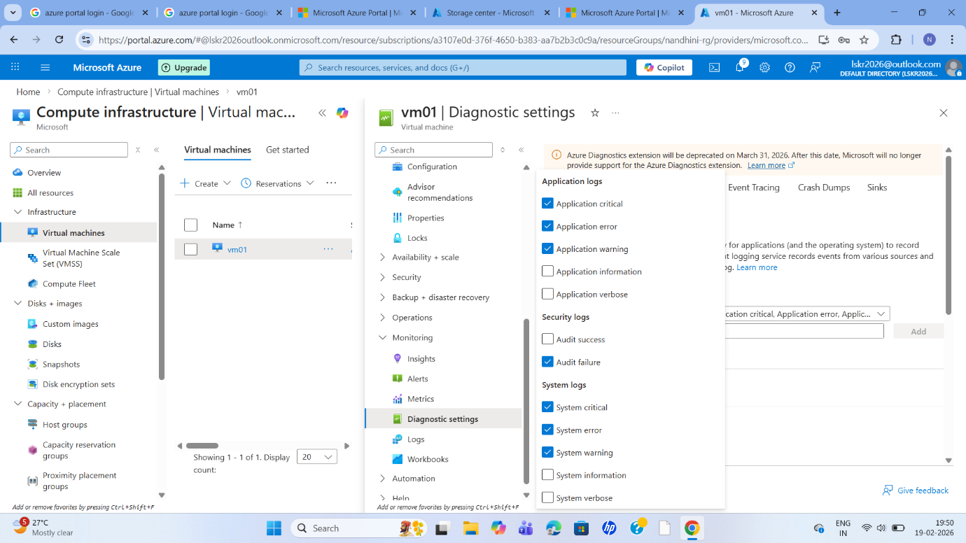
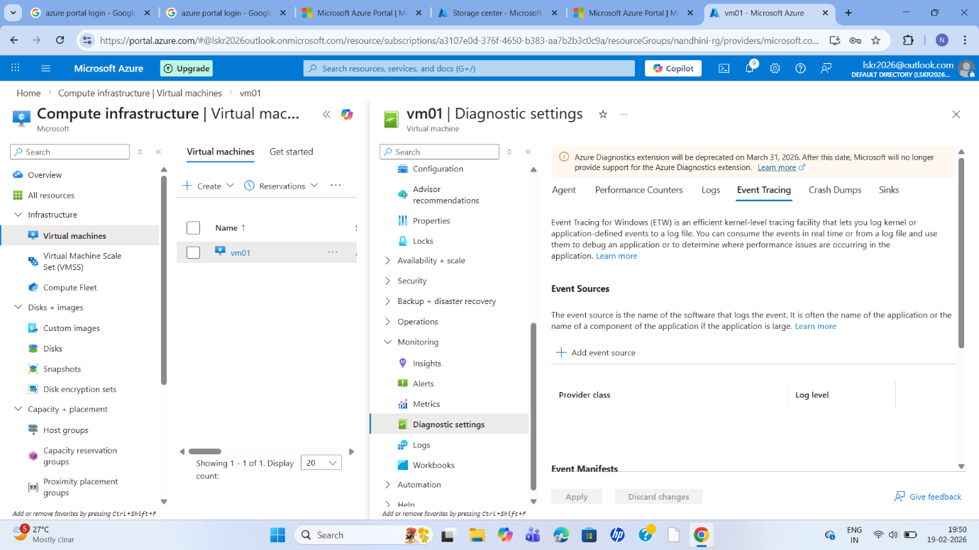
Now let me apply this,
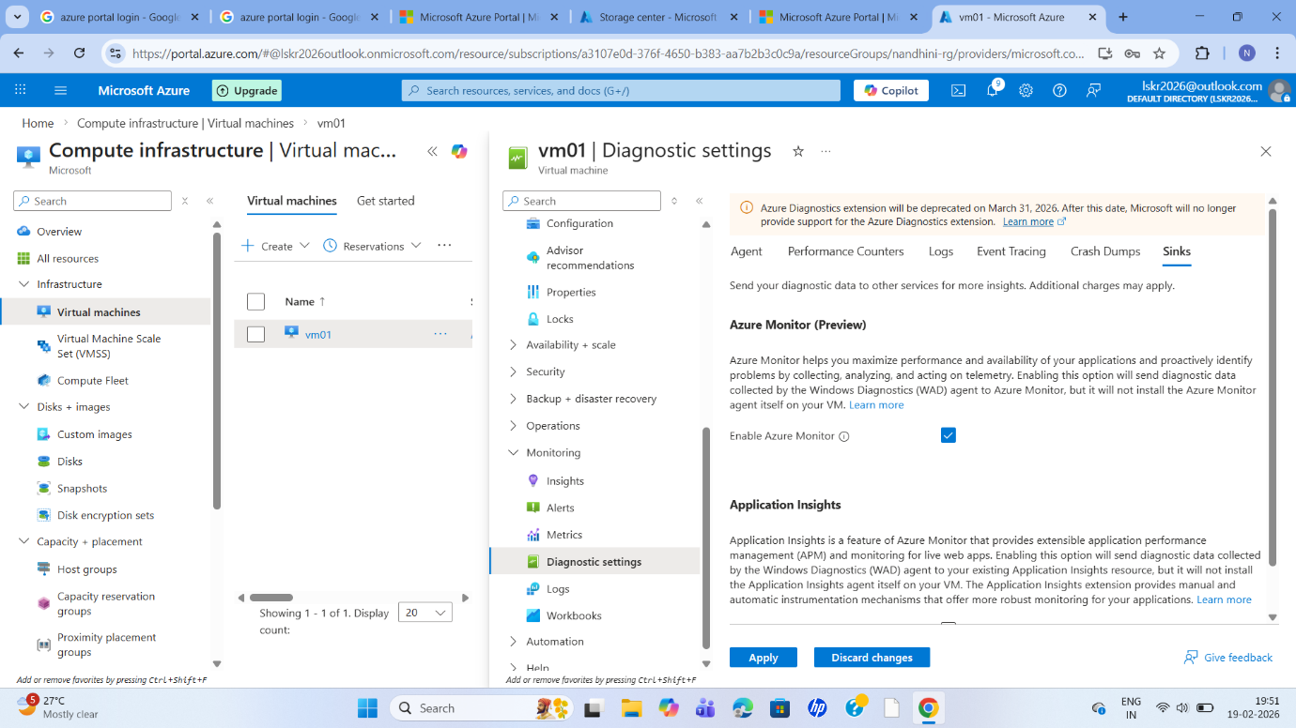
The public Ip address is assigned to the virtual machine.
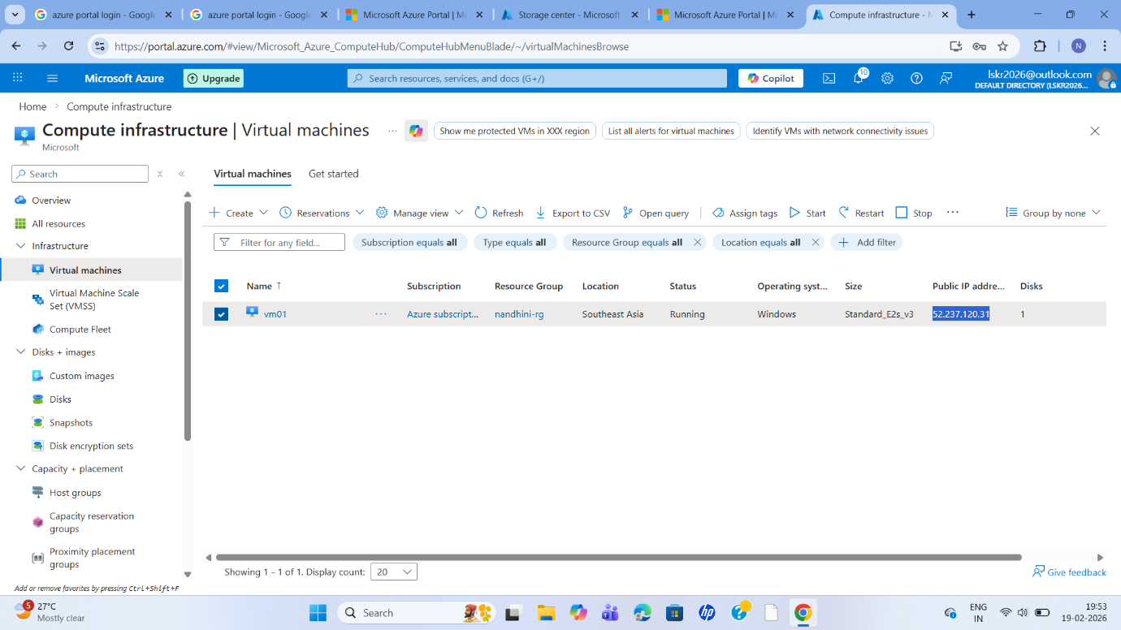
After that Remote Desktop Protocol (RDP) is used to connect to the windows virtual machine.
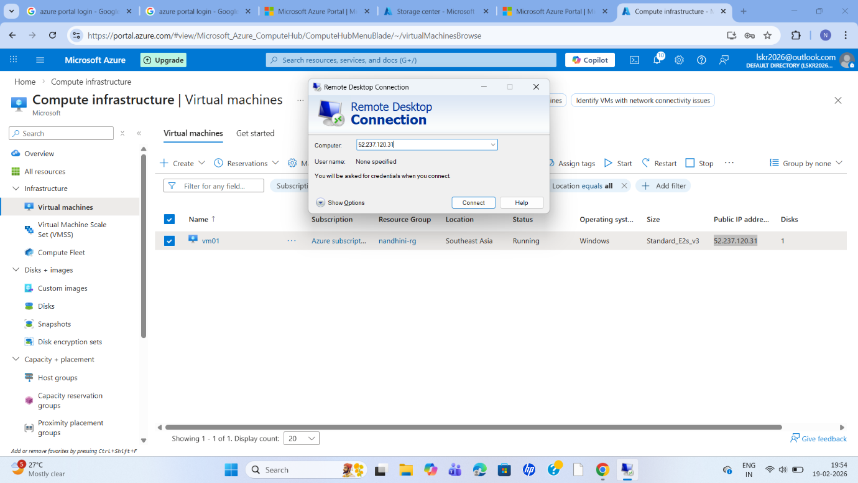
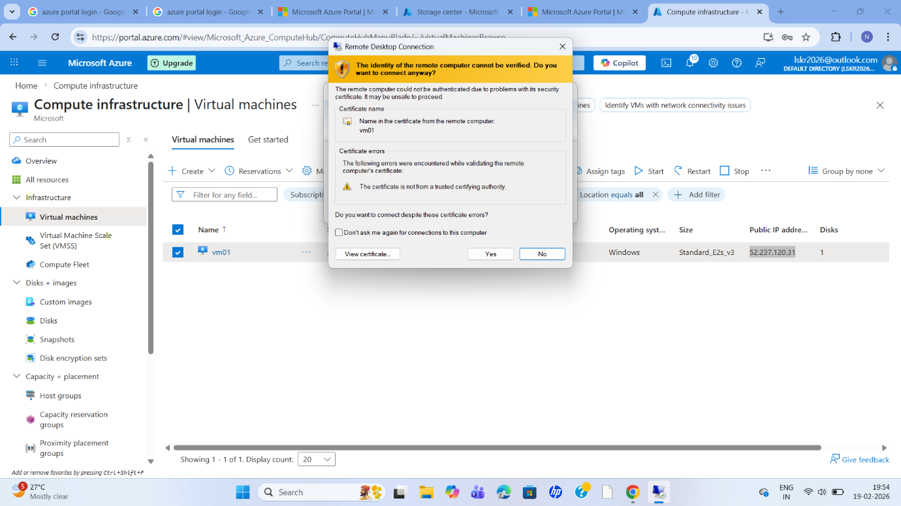
Configure an inbound security rule for remote desktop access
And save
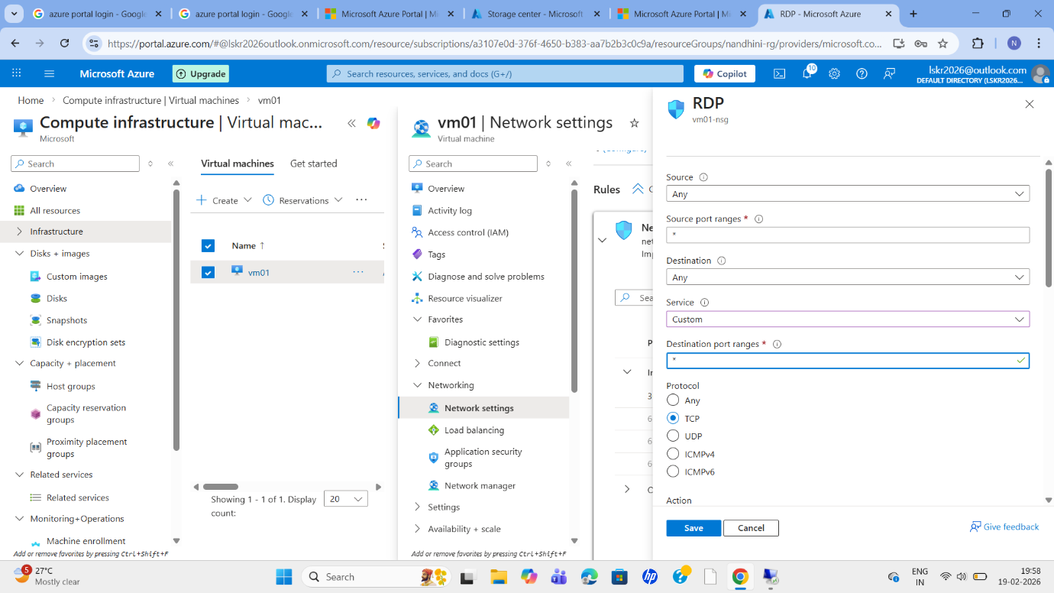
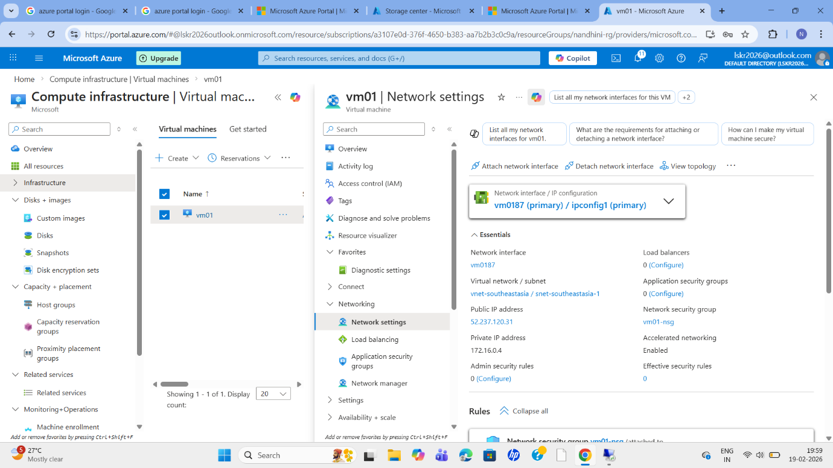
Now I select a Metrics;
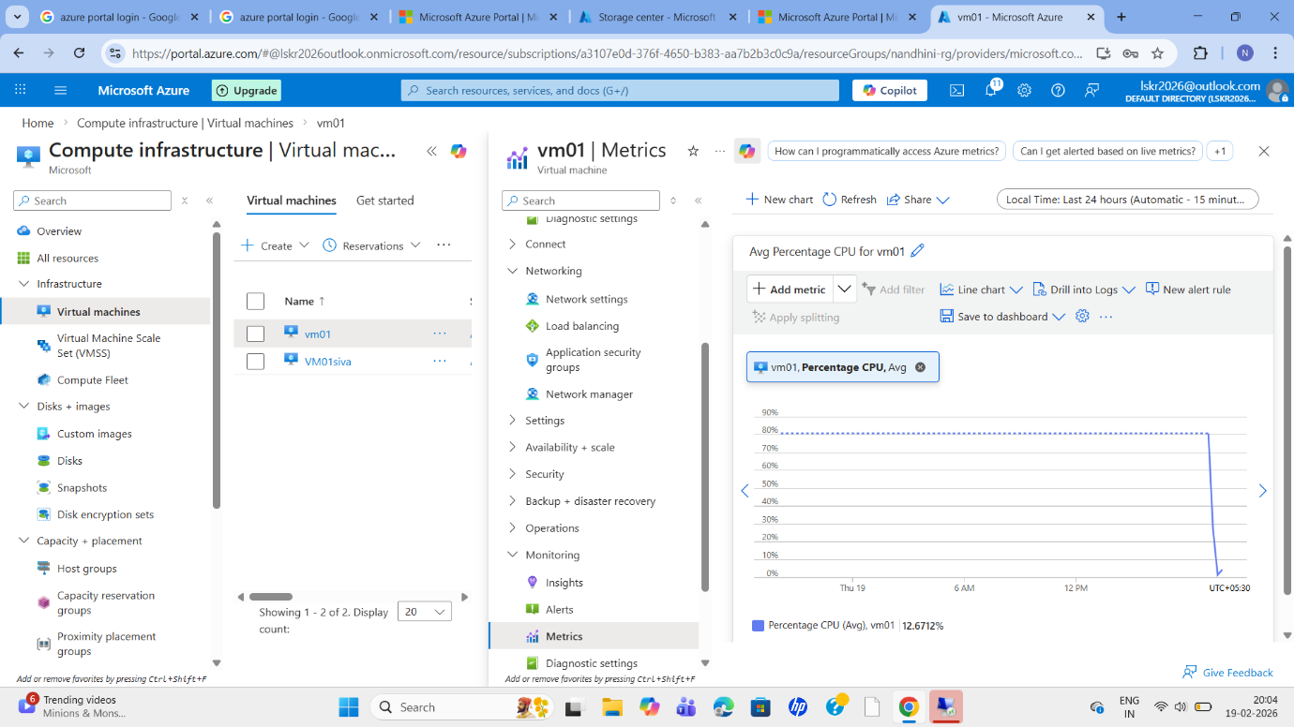
And save dashboard
And after create an alert rule;
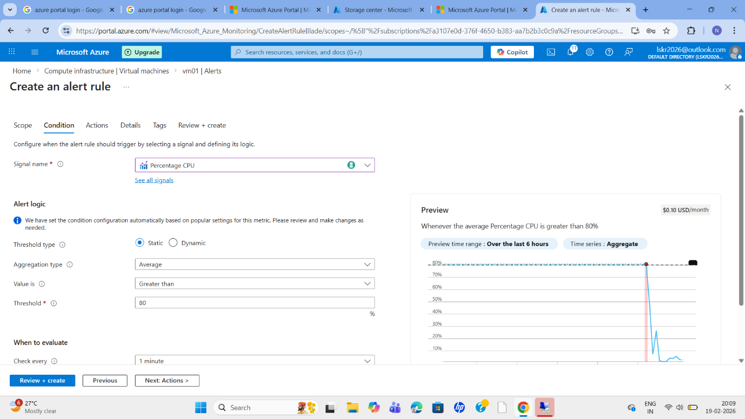
Now create actions group
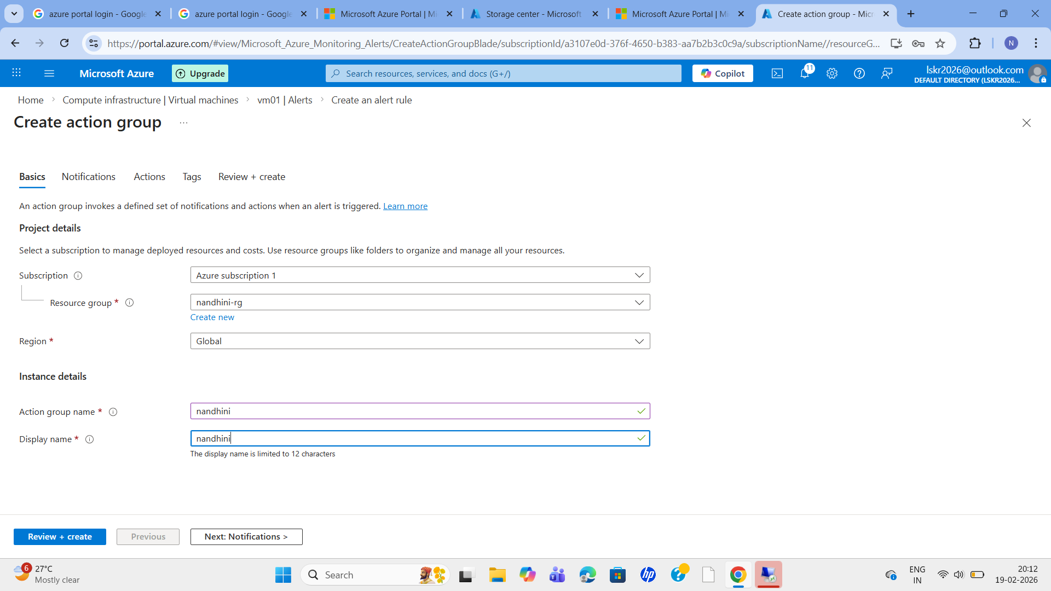
Next notification;
So I am going to only emails
So I am adding email here
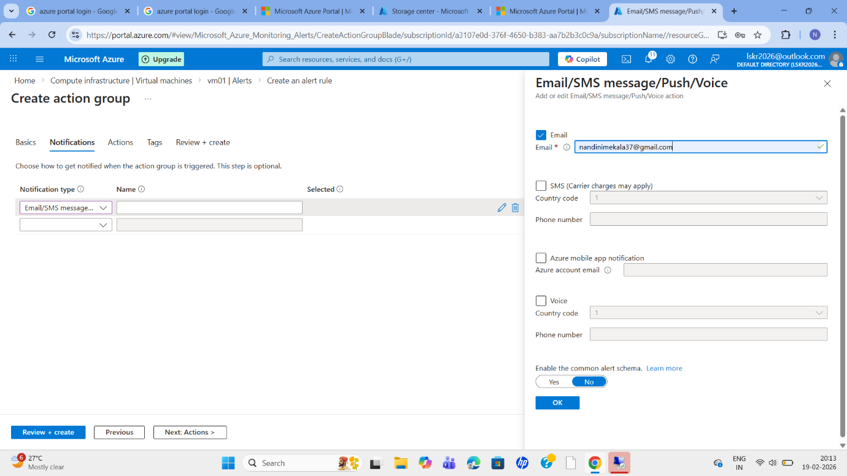
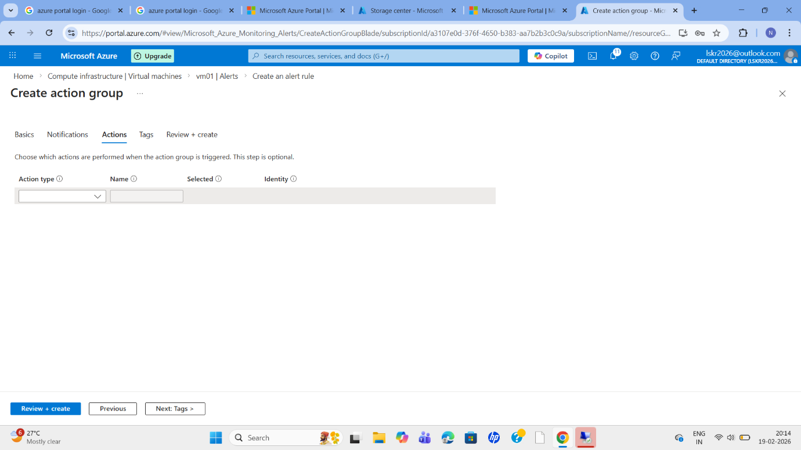
And create
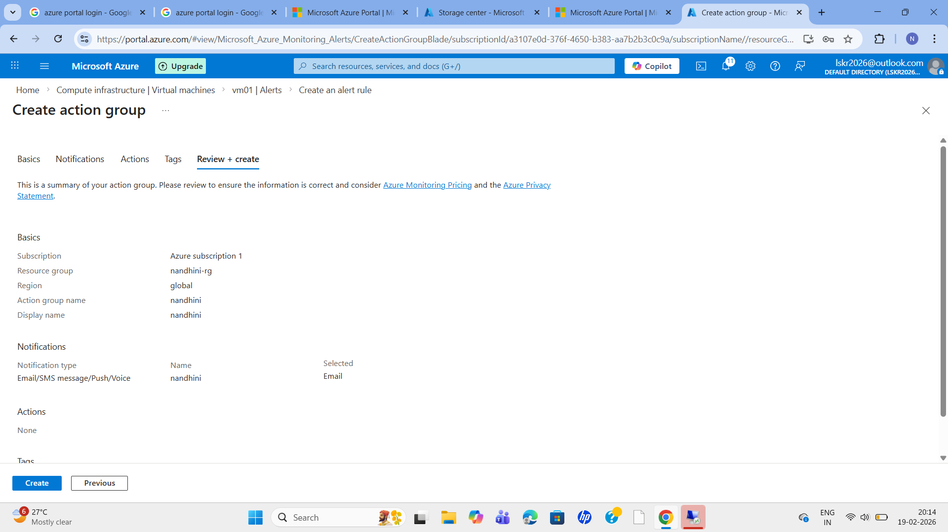
Now go to our created vm which we logged in -open Microsoft edge-and download
Stress software our vm-overview monitoring metrics
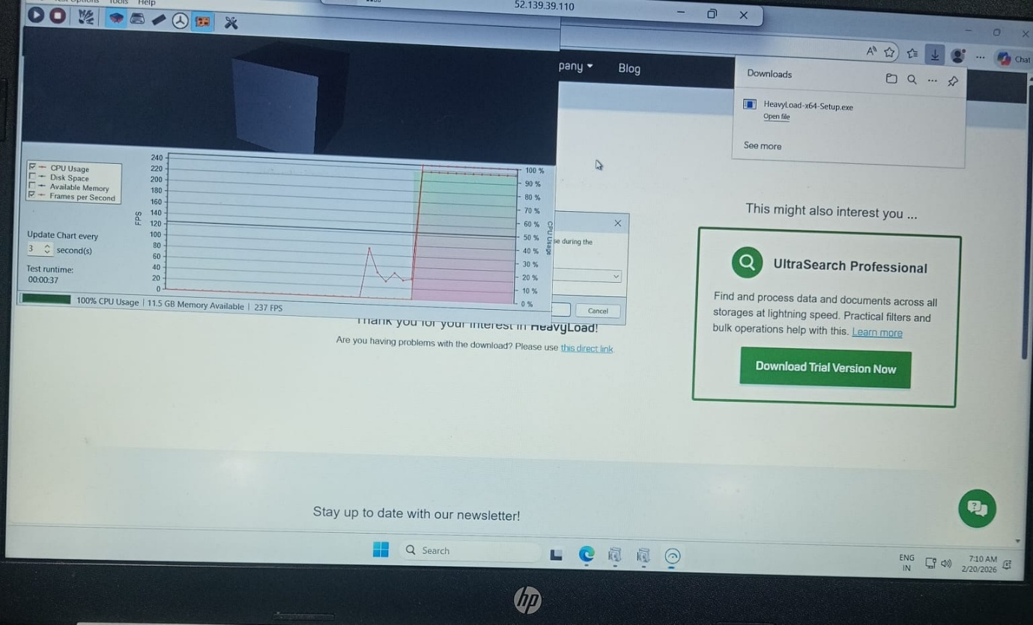
Here if it is <40, than email will be sent
